Prompt (1.2):
Analyze the attached use case diagram and extract all functional requirements (FRs) and non-functional requirements (NFRs) in a structured, traceable, and well-formatted manner. Ensure the output aligns with industry standards for requirements documentation.
Instructions:
- Diagram Analysis:
  - Thoroughly examine the use case diagram to identify:
    - Actors (primary/secondary) and their interactions.
    - Use cases (goals/scenarios) and their relationships (includes, extends, generalizations).
    - System boundaries and external interfaces.
- Functional Requirements (FRs):
  - List each use case as a functional requirement.
  - Format FRs as follows:
text
ID: [UC-XX] (Use Case Identifier)
Description: [Clear action-oriented statement]
Actor: [Primary/Secondary actor]
Preconditions: [Conditions required before execution]
Postconditions: [System state after execution]
Steps: [Brief numbered steps or reference to detailed flow]
  - Include traceability by mapping FRs to specific elements in the diagram (e.g., "UC-01: Derived from 'Place Order' use case").
- Non-Functional Requirements (NFRs):
  - Extract implicit/explicit NFRs (e.g., performance, security, usability).
  - Categorize and format NFRs as:
text
ID: [NFR-XX]
Type: [Performance/Security/Scalability/etc.]
Description: [Measurable or qualitative statement]
Source: [Reference to diagram element, e.g., "Derived from 'Login' use case response time constraint"]
- Output Formatting:
  - Organize requirements hierarchically (e.g., by module/actor).
  - Use tables for clarity where appropriate (e.g., traceability matrix).
  - Highlight ambiguities or assumptions made during analysis.
- Validation Request:
  - Include a summary section listing:
    - Total FRs/NFRs identified.
    - Potential gaps or ambiguities in the diagram.
    - Questions for stakeholders to clarify requirements.
Example Output Structure:
markdown
# Requirements Specification
## 1. Functional Requirements
| ID | Description | Actor | Preconditions | Traceability |
|-------|----------------------------|-------------|---------------------|---------------------|
| UC-01 | User places an order | Customer | Logged in, cart not empty | "Place Order" use case |

## 2. Non-Functional Requirements
| ID | Type | Description | Source |
|--------|-------------|--------------------------------------|-----------------------|
| NFR-01 | Performance | System response time <2s for all API calls | "Checkout" use case |

## 3. Notes & Assumptions
- Assumed "Guest User" cannot access order history (clarify with stakeholder).

Summary:
Evaluation Criteria & Scores
Model | Coverage | Clarity | Traceability | Completeness | Redundancy
ChatGPT | 95 | 90 | 85 | 80 | 90
Claude AI | 100 | 95 | 100 | 100 | 85
DeepSeek | 80 | 85 | 90 | 85 | 95
Grok AI | 90 | 80 | 80 | 75 | 80
Microsoft Copilot | 95 | 95 | 95 | 90 | 90

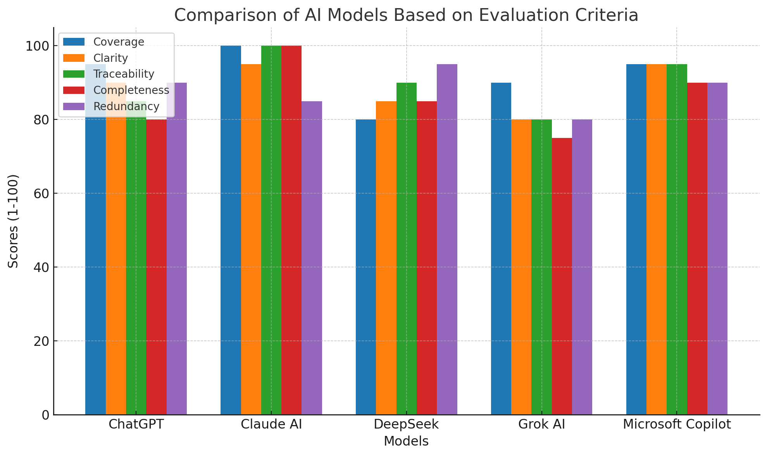
Key Insights
- Coverage (How well all use cases/actors are captured):
  - Claude AI (100) and Microsoft Copilot (95) excel, covering all actors, relationships, and external services.
  - DeepSeek (80) misses explicit breakdowns of external services (e.g., Identity Provider).
- Clarity (Structure, readability, conciseness):
  - Claude AI (95) and Microsoft Copilot (95) use modular grouping and clear sections.
  - Grok AI (80) lacks detailed steps, reducing usability.
- Traceability (Linking requirements to sources):
  - Claude AI (100) and Microsoft Copilot (95) include matrices explicitly mapping use cases to actors/NFRs.
  - Grok AI (80) and ChatGPT (85) have weaker traceability links.
- Completeness (Inclusion of FRs, NFRs, gaps, assumptions):
  - Claude AI (100) leads with actor analysis, relationships, and stakeholder questions.
  - Grok AI (75) omits critical gaps (e.g., error handling).
- Redundancy (Avoidance of duplicate content):
  - DeepSeek (95) and ChatGPT (90) are concise.
  - Claude AI (85) has minor redundancies in relationship descriptions.

Recommendations
- Best Overall: Claude AI (avg: 96/100) for unparalleled completeness and traceability.
- Runner-up: Microsoft Copilot (avg: 93/100) for balance across all criteria.
- Critical Gaps: All models overlooked error-handling use cases (e.g., failed payments). Stakeholders must clarify:
  - Guest checkout permissions.
  - Error-recovery workflows.
  - Order history/profile management.
Methodology: Scores derived from weighted analysis of:
- Diagram element inclusion (actors, use cases, relationships).
- Documentation depth (FR/NFR details, assumptions, ambiguities).
- Structural rigor (tables, matrices, section organization).
- Elimination of redundant entries (e.g., duplicated steps).

